Mechanical vs. Fixed Blade Broadheads

By Brian Swiger and Todd Jones
On my first trip to northern Canada, the locals spoke about an elderly gentleman who was known to use his “big gun” when hunting polar bears. This big gun was a 222 Remington. Some of the locals considered that caliber to be excessive. After all, they often hunted polar bears with a 22 magnum. I later learned that the locals preferred smaller calibers since the guns were less expensive, and the ammunition was easier to obtain in that part of the world. I suppose a 222 Remington, or even a 22 magnum, would work on polar bears. But in reality, those guns are not guns of choice when hunting polar bears.
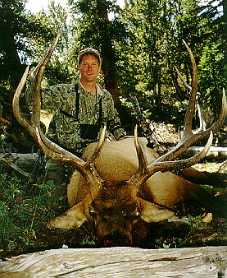
The same can be said for mechanical broadheads and elk. Only the smallest percentage of bow hunters shoot equipment which is set up in a manner which will enable the hunter to consistently harvest elk with mechanical broadheads. I emphasize “consistently” and the “smallest percentage” – probably less than two percent. Sure, it can be done, has been done and people will continue to try. But if you are going to be hunting elk with the East Fork gang, the best advice I can give you is to leave the mechanical broadheads at home. More likely than not, you are going to wound an elk with mechanical broadheads. If you don’t believe me, just ask Todd to give you a rough estimate as to the number of his hunters that have harvested elk with mechanicals, versus those that have lost elk with mechanicals.

Generally, hunters use mechanical broadheads because they think mechanicals will fly better, and will be easier to shoot. To a certain degree they are correct. But if we apply that same logic, why not use a field tip? After all they fly better than mechanicals, and are the easiest to shoot. Now days, the bows that are out there are almost dummy proof. Set your tiller even, your nocking point level, and select arrows to match your draw weight. If you do, your bow will out shoot you! You may have read articles about tuning your bow by making sure that your broadheads impact in the same location as your field tips. If so, attempt to forget everything your read. It is possible to get your broadheads and field tips to impact in the same spot. It is also possible to take a polar bear with a 22 magnum.

The four mistakes that most hunters make when using fixed blade heads involves
(1) Failing to install the broadhead so that it spins true and in perfect alignment with the shaft;
(2) Failing to sight in their bows with fixed blade broadheads;
(3) Failing to shoot each broadhead/arrow combination prior to taking it a field (make sure you insert new blades before going a field); and
(4) Failing to realize that sometimes, for unknown reasons, a particular arrow or broadhead just will not shoot well.
So, take a little extra time to make sure your broadheads spin true. After your broadheads are properly installed and aligned, number each arrow separately. If eight of your arrows shoot well, and two do not, leave those two at home. It is that simple.
Bowhunters often want to use mechanicals to increase their “effective shooting range”. Unfortunately, as the distance of the shot increase, the amount of energy, which is available for penetration, decreases. In the case of fixed blades versus mechanicals, it takes more energy to push a mechanical through an elk than it does to push a fixed blade through that same elk. So even if you can hit that elk at 40 yards with your mechanical broadhead, you may not have enough energy to push that mechanical through both lungs, and even one lung. Even if you can hit the elk at a greater distance with mechanical broadheads, your “effective shooting range” for mechanicals is probably not greater than your “effective shooting range” for fixed blades. So don’t be so concerned about how far you can accurately shoot a mechanical head. Be more concerned about what that head is going to do once it gets to the target. After all, if you are chasing elk with the East Fork gang, you are more likely to have a problem getting a shot off due to the elk being too close, than too far. After all, my elk kicked me in the shoulder last year.
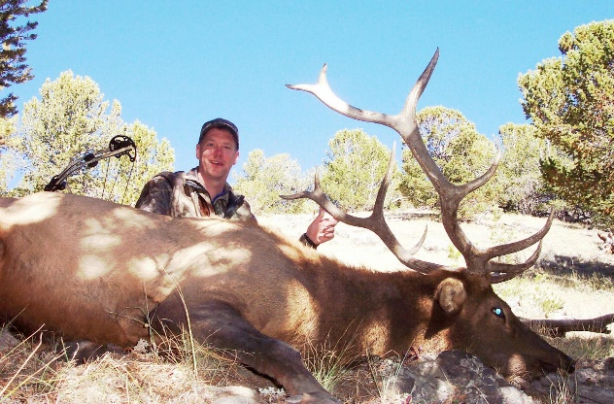
All things being considered, it shouldn’t take you any longer to get things set up for fixed blade broadheads (assuming you have undamaged heads that are properly aligned). You might be able to shoot a little further with mechanicals, and you may even be slightly more accurate. But an elk has a large kill zone, and is far more likely to expire quickly and in a humane manner when using fixed blade broadheads. So when you leave for Wyoming this year, leave those mechanical broadheads at home.
Here is a list of equipment that I would recommend as a bow hunter and outfitter for back country western big game.
- Arrows - (9 to 10 grains per inch) Kinetic energy is what we are looking for and not speed. 500+ grains total for arrow and broadhead combination. (EASTON, CARBON EXPRESS,BEMAN) Be sure that the arrows are the correct spine for your bow and broadhead combination. This information can be found on the web or at your local PRO shop. Arrows and broadheads are a key piece of equipment that is most overlooked and last item considered when preparing for a trip of a life time. Spend the time to find the right product that works for your specific application.
- Peep - Rubber tubing is asking for problems.
- Sight - Look for a rock solid sight that can take some abuse. If your sight has a light on it get rid of it, state regulation and P&Y violation.

