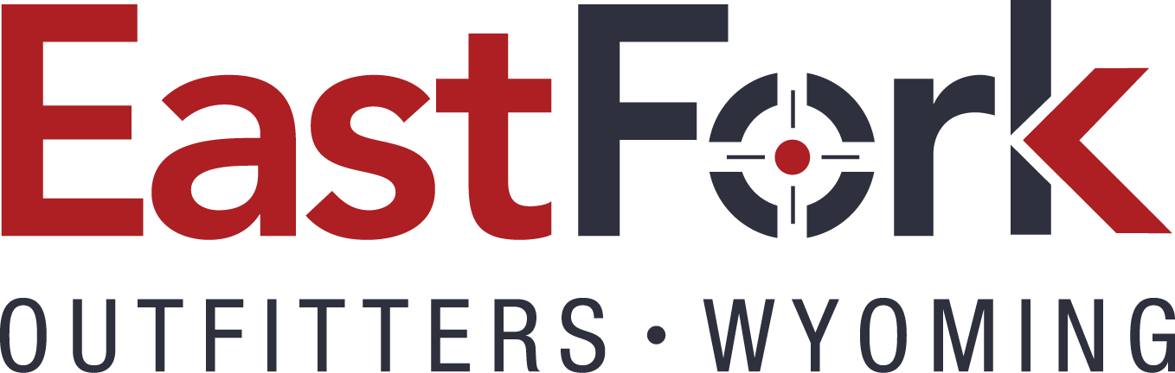

This informational letter is to help avoid some mistakes made yearly and answer some commonly asked questions we get each year.

Safety will be first and foremost in everyone’s mind, especially with regards to firearm safety. We require that all firearms be unloaded when carried. The guide will instruct you when you can fill your magazine or clip. While hunting never chamber a round until instructed to do so by your guide. Please don’t be afraid to ask your guide. Open your bolt prior to scabbarding your firearm so that your guide can inspect the chamber. While in camp all firearms are to remain empty. Muzzle control shall be demanded at all times. If the guide tells you to watch your muzzle, immediately point it in a safe direction and do not make that mistake again.

All Wyoming Game and Fish Laws will be strictly adhered to, NO EXCEPTIONS. The license issued to you cannot be transferred to another hunter; your hunt will be ended immediately if this is tried. Take a picture ID with you in the field just in case we have a Game Warden check (yes, Wyoming wardens have been known to be out on horseback). If you were born after January 1, 1966, you will also need to carry a valid hunter’s safety certificate from your state.

We recommend that you purchase travel insurance. Ripcord Travel Insurance is recommended. This insurance provides trip cancellation, interruption, some medical, and lost or damaged equipment. We have had several people use this insurance and all of the feedback has been very positive. Contact us if more information is needed.

Camp has an assigned manager, that’s me, Taylor, unless something happens. If you have any problems or concerns, please discuss these with me immediately. It’s best to solve problems quickly rather than letting them build.

It is very important to bring all the necessary gear. Please read our suggested gear list. If you intend to purchase a new pair of binoculars I would recommend 10 power, but it is not necessary to rush out and buy a new pair if you already own them. Boots should be warm but with medium lug soles so they can fit in a stirrup. For pack in hunts, please bring two long duffle style bags to put all of your gear in. They should be at maximum ¾ full. If the number of bags is a consideration for those of you flying, use a large bag to get your gear out here then repack it into the duffle sized bags. Once again follow the equipment list and you will be fine.

Hunt of a Lifetime? We certainly hope you feel this way! You must have a realistic expectation of your hunt. Empowering yourself by asking the right questions before you get out here and while you are hunting. Communication with your guide is of utmost importance. If your hunt is not going as you expected, your horse just isn’t right, you are cold at night, or any issue that arises while you are in camp needs to be voiced to any of our staff (camp manager, guide, cook, or wrangler). We are not super human and we do not read minds. It is best to bring it to our attention right away so we may correct the situation. East Fork Outfitters does not guarantee a harvest of an animal or whether or not you will have the greatest time of your life but we will certainly do the best job that we humanly can.

Do I need to wear orange? Yes, for firearm hunters. A cap will fulfill the requirement, but we suggest a noiseless fabric orange vest as it can be worn over heavy coats or lighter gear if the weather is warm.

I receive many questions each year but the number one question asked of me is in regards to tipping. Who do I tip, how much and when? First I’ll address the guide’s tip. The customary amount is 10% of your hunt price. For example, an elk hunt tip for each hunter would be $450 to $600 on average. The best time to tip your guide is right at the harvest site, the same day back at camp, or as you are leaving camp. It is always good to hand the gratuity directly to the person it is intended. The cook and the wrangler receive approximately $100 from each hunter. The reason I have included this section is that so that you can foresee all potential expenses. Guides, cooks and wranglers work very hard and count on their tips as part of their compensation. Remember these are guidelines. A tip is a reward for doing a great job and is a personal matter.

Is alcohol allowed in camp? Yes. However, no alcohol is to be consumed during the day of hunting. Once you are done for the day and your weapon is put in the rifle tent, then consuming alcohol in moderation is permissible. If anyone compromises the safety or experience of others, that person will be packed out of camp for good. Alcoholic beverages and soda must be purchased prior to leaving town. As we are a “pack in” camp no more than one liter bottle of alcohol or 2 six packs of beer will be packed per person. Just a note: most of our hunters have found that there is little time to drink in camp if they are to get enough rest and be ready for the next day. Beverages provided in camp include Gatorade, coffee, water, tea and hot chocolate.

Do I need to purchase a Conservation Stamp? No. We will purchase the stamp for you and charge your account. We have had many hunters in the past forget to buy them prior to going into camp. This eliminates any unnecessary time, travel, and problems for all.

Practice your shooting. I recommend no less than 100 rounds of ammo at the range (more is better). Practice your shots out to 300 yards. One-fifty to two hundred yards is the norm. Be sure to practice in all positions: off-hand standing, standing with a rest, sitting and on your belly. Bring a scoped rifle you know and feel comfortable with. On elk, I don’t recommend anything lighter than a 270.

Wounded Animal Policy. Our policy in regards to a wounded animal is very simple, “If you draw blood, whether you and your guide find the animal or not, that is your animal.” Another animal will not be taken. We will do everything in our power to find and retrieve the animal. If you need further clarification please ask.

Physical conditioning cannot be emphasized enough. Walk, ride a bike, and climb stairs. All will help to improving your chances of success and your experience. If you don’t know how to ride take some lessons at a local stable. Even if you know how to ride, get out and ride some before you get here. It will help your conditioning and keep you from getting as sore.

Horsemanship is a must. This is your hunt. You didn’t come on your trip for riding lessons, nor do we provide them. If you are not familiar with horses we encourage you to educate yourself and take some basic riding lessons. If you have not ridden in years, we encourage you to get accustomed once again to horses. You will be in the saddle every day while hunting and are expected to be able to control our gentle, well-mannered horses and mules.

I hope this helps answer those last minute questions. Remember we are very busy during the summer and fall, but if you call or leave a message via e-mail (taylor.engum@gmail.com) we will do everything in our power to answer your questions and requests.

