Riding a horse can be a necessary component of a successful hunt, especially in the big country of the West, where the continent’s biggest game lives. But horsemanship isn’t an innate skill, and sloppy or nervous riding can sour a hunt in a hurry. These tips won’t guarantee hunting success, but they’ll definitely boost your confidence. And that’ll increase your chance of bringing home a trophy.
1. Getting On (and Off!)
Sounds like a no-brainer, but hunting on horseback requires climbing on and off horses. If game appears unexpectedly, you’ll want to be able to slide off fast. Hopping on quickly increases your hunting time. So practicing getting on and off a horse before the hunt is time well spent. Mount and dismount—with the exception of a few special circumstances—on the left side of the horse.
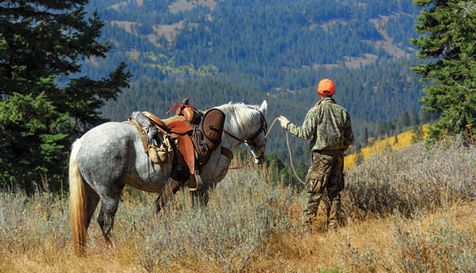
TIP: Always check that the cinch is tight before getting on a horse.
2. Adjusting Stirrup Length
Long stirrups lead to a sore butt; short stirrups mean sore knees. But don’t worry—they’re easily adjusted. What’s the perfect length? Once you’re mounted, put your feet in the stirrups and stand up. If your crotch clears the saddle by a couple of inches, then your stirrups are just right. If you’re pointing your toes while seated, the stirrups are too long. If your knees are really bent, then they’re too short.
TIP: Longer stirrups are more comfortable.
3. Applying Gas, and Brakes
Nothing’s worse than feeling out of control when you’re riding. So learn the controls. When you kick or flap your legs, the horse will go; pull on the reins, and it’ll slow down or stop. Steer by “neck-reining”—laying the reins across one side of the neck or the other—or by direct pull. Pull on the left rein and the horse turns left; pull on the right rein to turn right.
TIP: Most trail horses want to stick with the herd and will resist a different course.
4. Tying Up
When you dismount, tying up your horse correctly means the difference between riding back to camp or slogging back on foot. The best tether is a quick-release knot. And while there are lots of different types, if the knot comes undone when you pull on the loose end, it’ll do. Any knot questions? Ask your wrangler.
TIP: Add a half hitch to any knot to ensure your horse won’t undo it himself.
5. Boosting your Cowboy Confidence
Feeling comfortable while on horseback means you’ll hunt better longer. So here are a few hints. Don’t be afraid to grab the horn of the saddle to steady yourself. Lean forward when riding uphill and back going downhill. Stay centered in the saddle, particularly when riding through swampy terrain. Don’t look at the water when crossing a river. And ask for a bombproof horse even if you’re an experienced rider. You want to be hunting, not training a horse.
June 17, 2014
Horseback Riding Tips for Hunters - 4
Tweet
by Tania Millen

